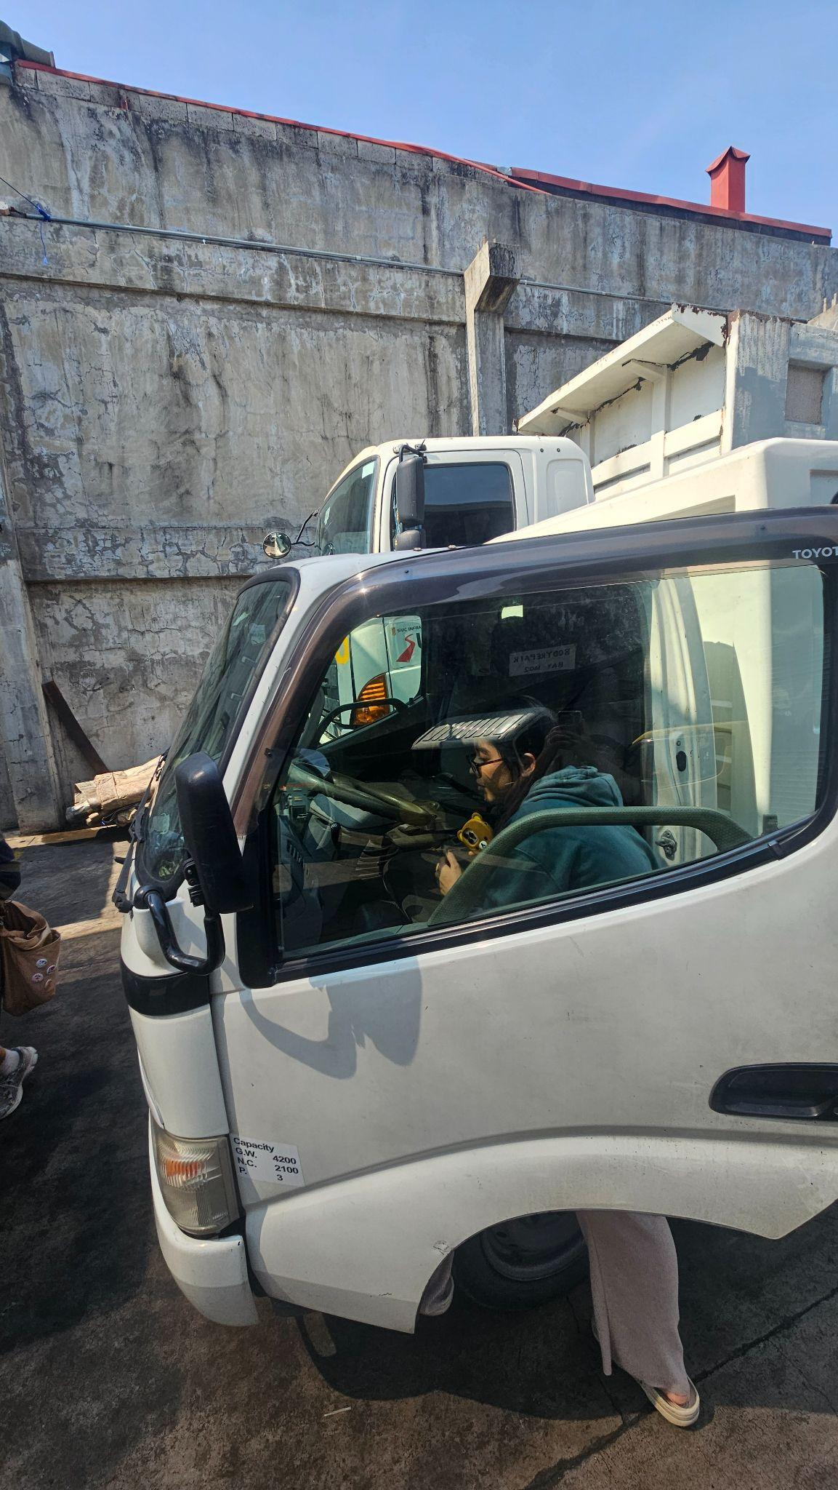
Figure X: researcher inspecting the cabin of a commercial truck at Hino Parañaque Subic GS Auto Inc. (SGSA). 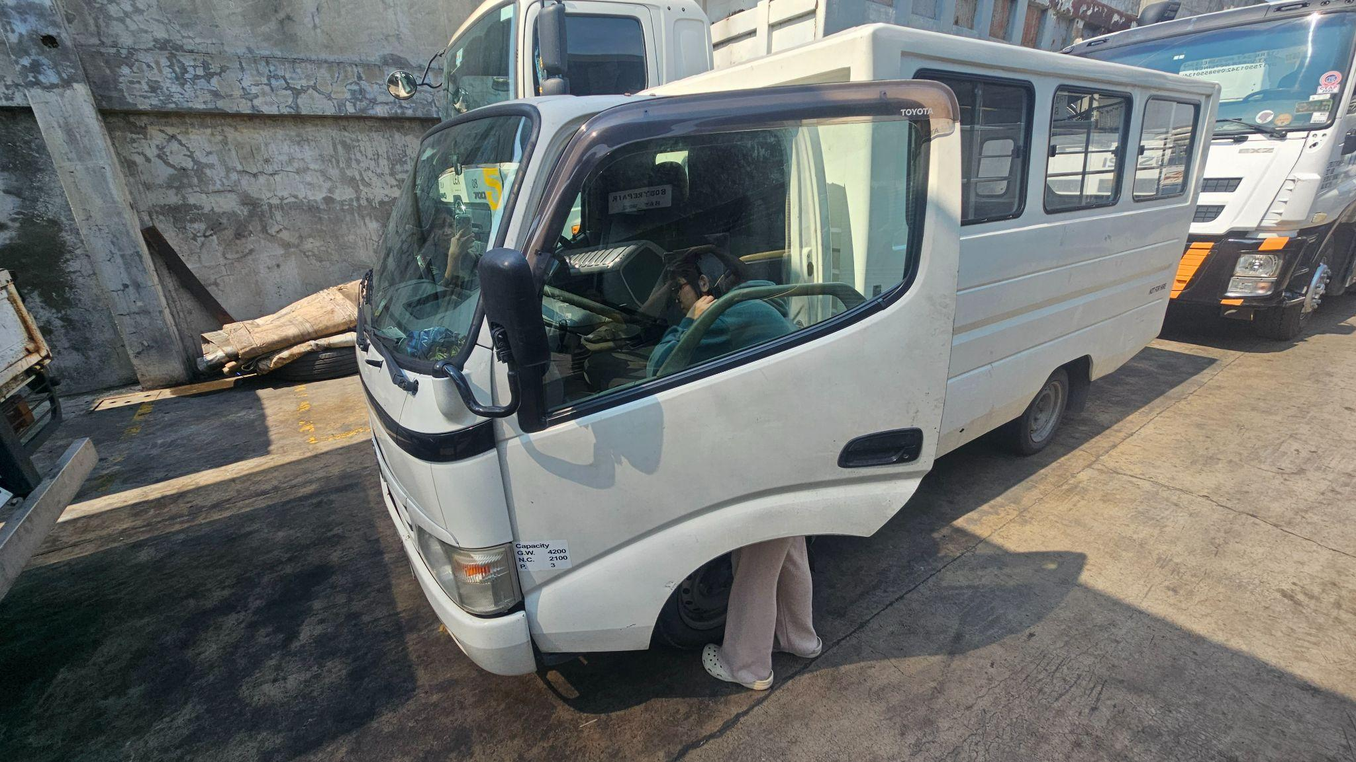Figure X: Further inspection of the sample vehicle at the partner company's facility.
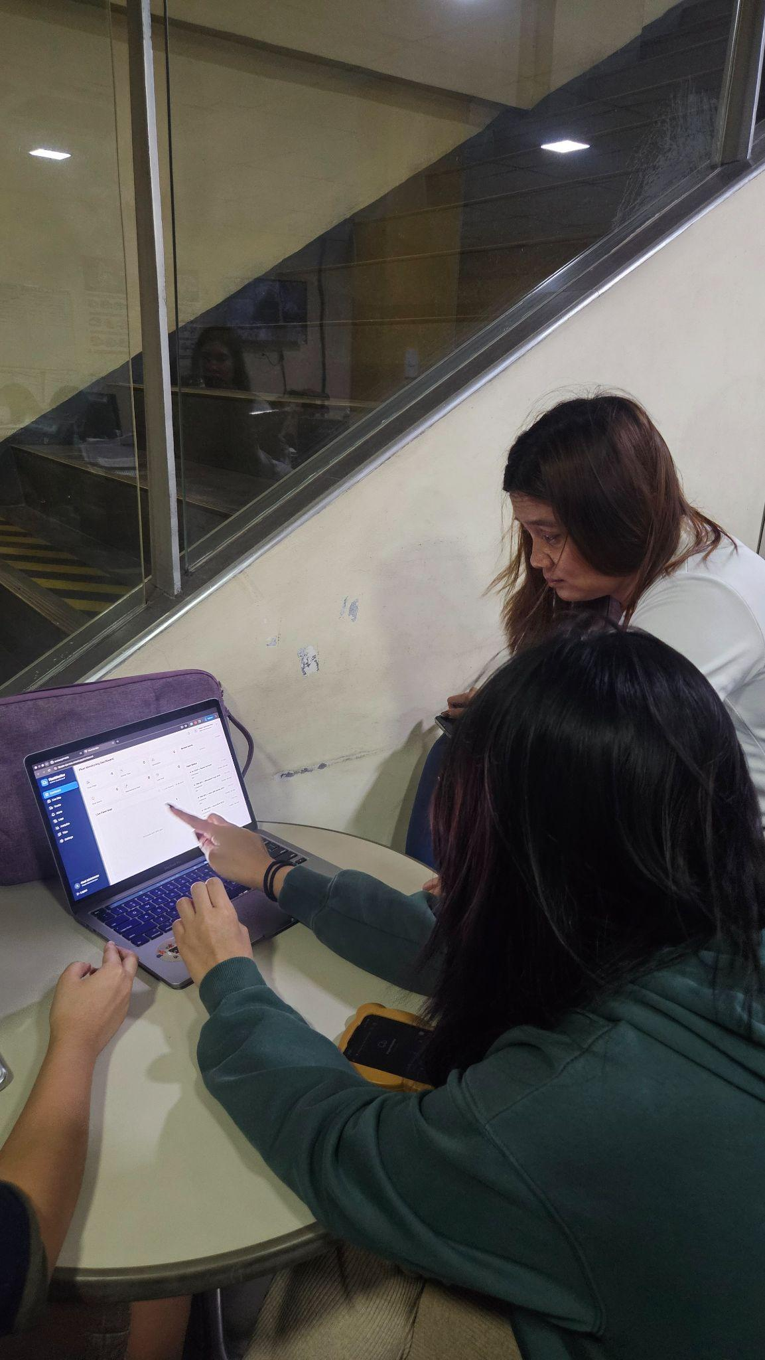
Figure X: Researchers and the partner company’s representative evaluating the cloud dashboard during prototype demonstration.

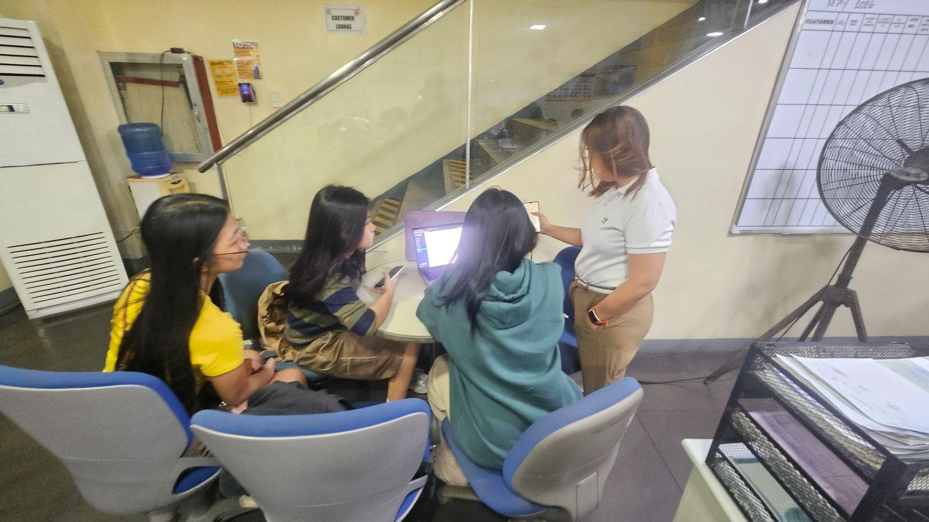
Figure X: A demonstration session of the prototype's web-based monitoring interface.

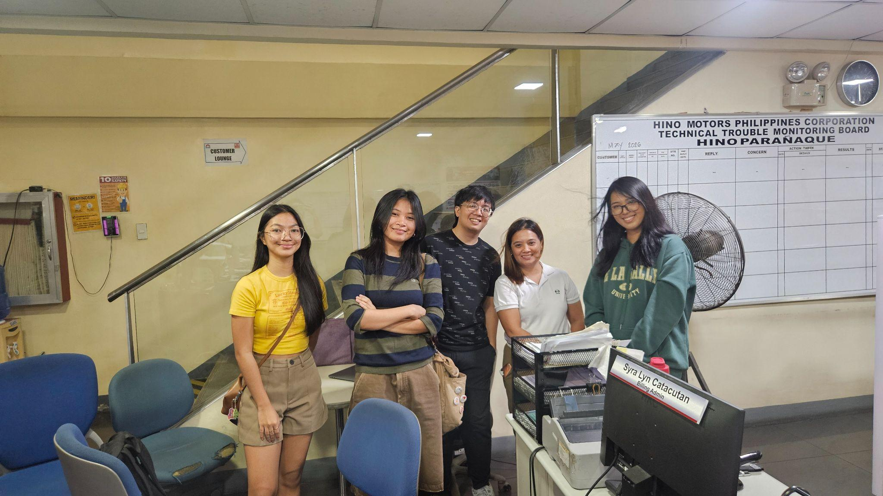
Figure X: The research proponents at the Hino Parañaque office following a successful meeting and demonstration of the prototype system with the partner company.


Figure X: The research team during the initial consultation meeting with the representative from Hino Parañaque Subic GS Auto Inc. (SGSA).


Figure X: A group photograph of the research team and the partner company's representative in the conference room.

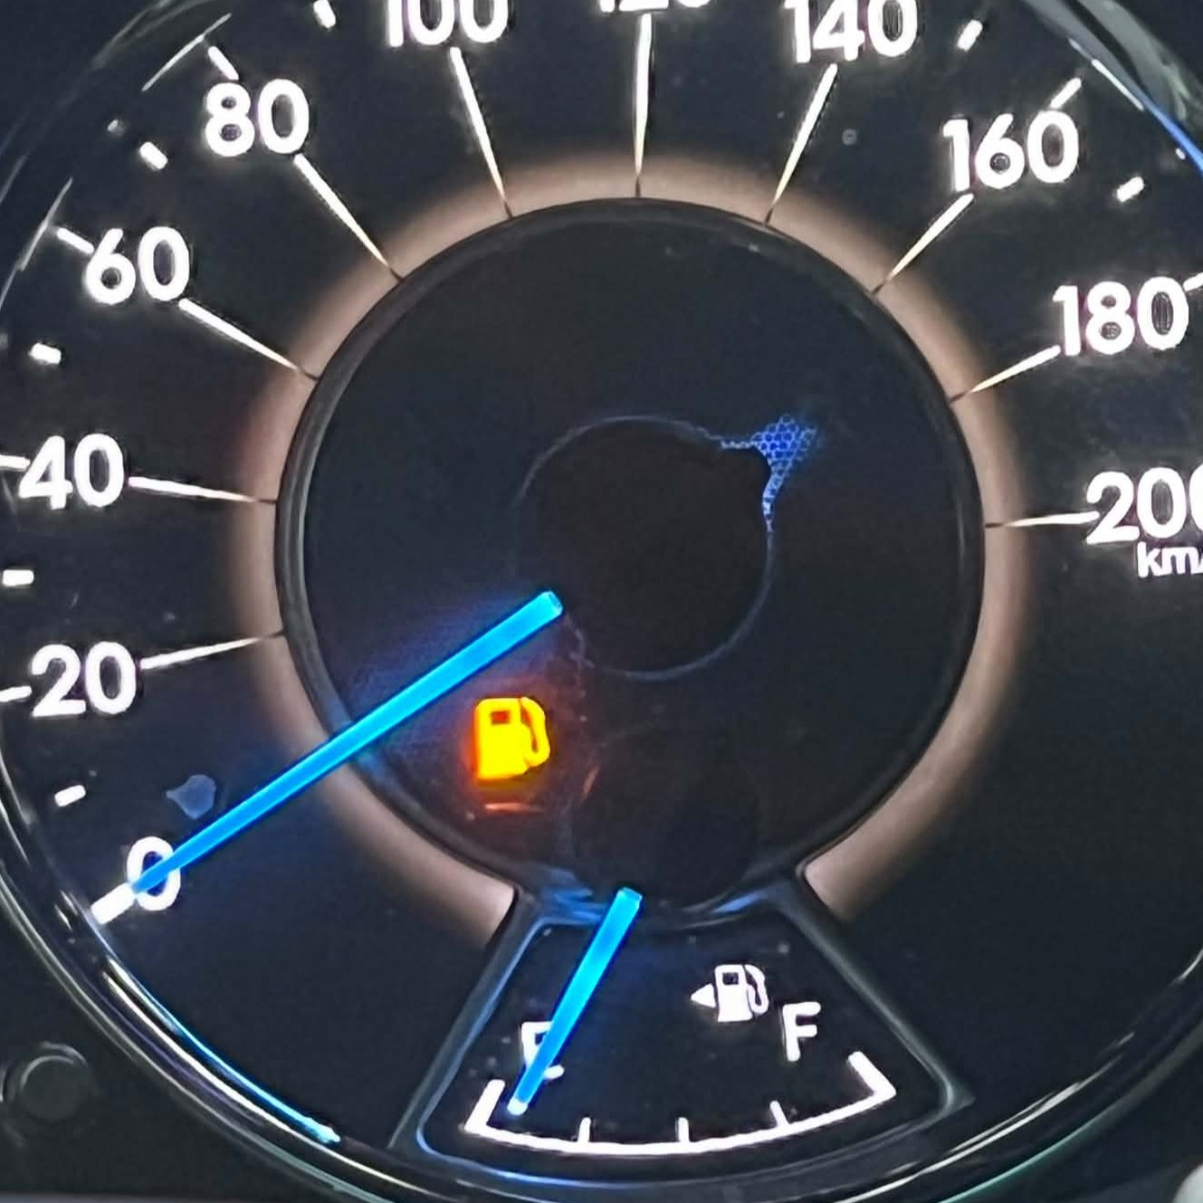
Figure X. Initial Fuel Level Reading
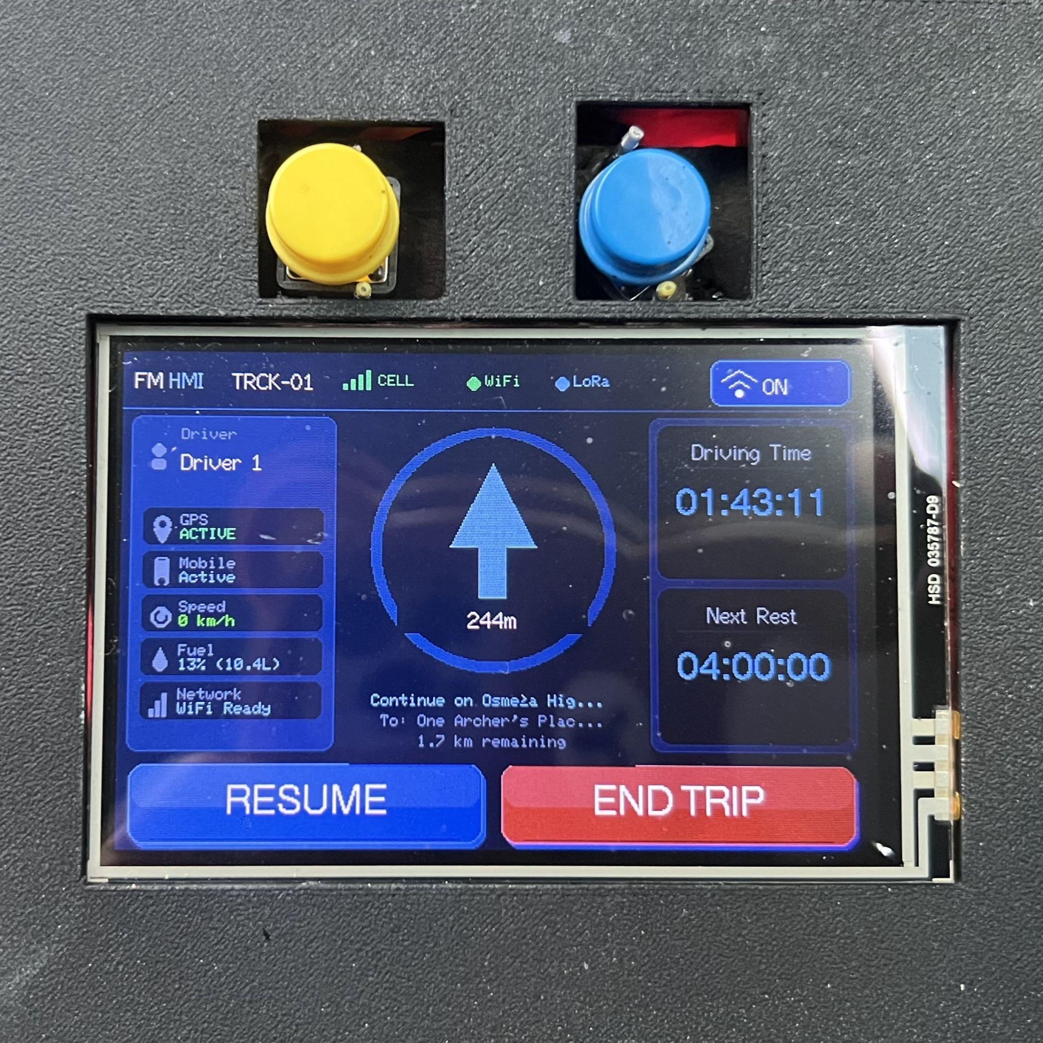
Figure X. Initial HMI Display Showing Fuel Level in Liters and Percentage
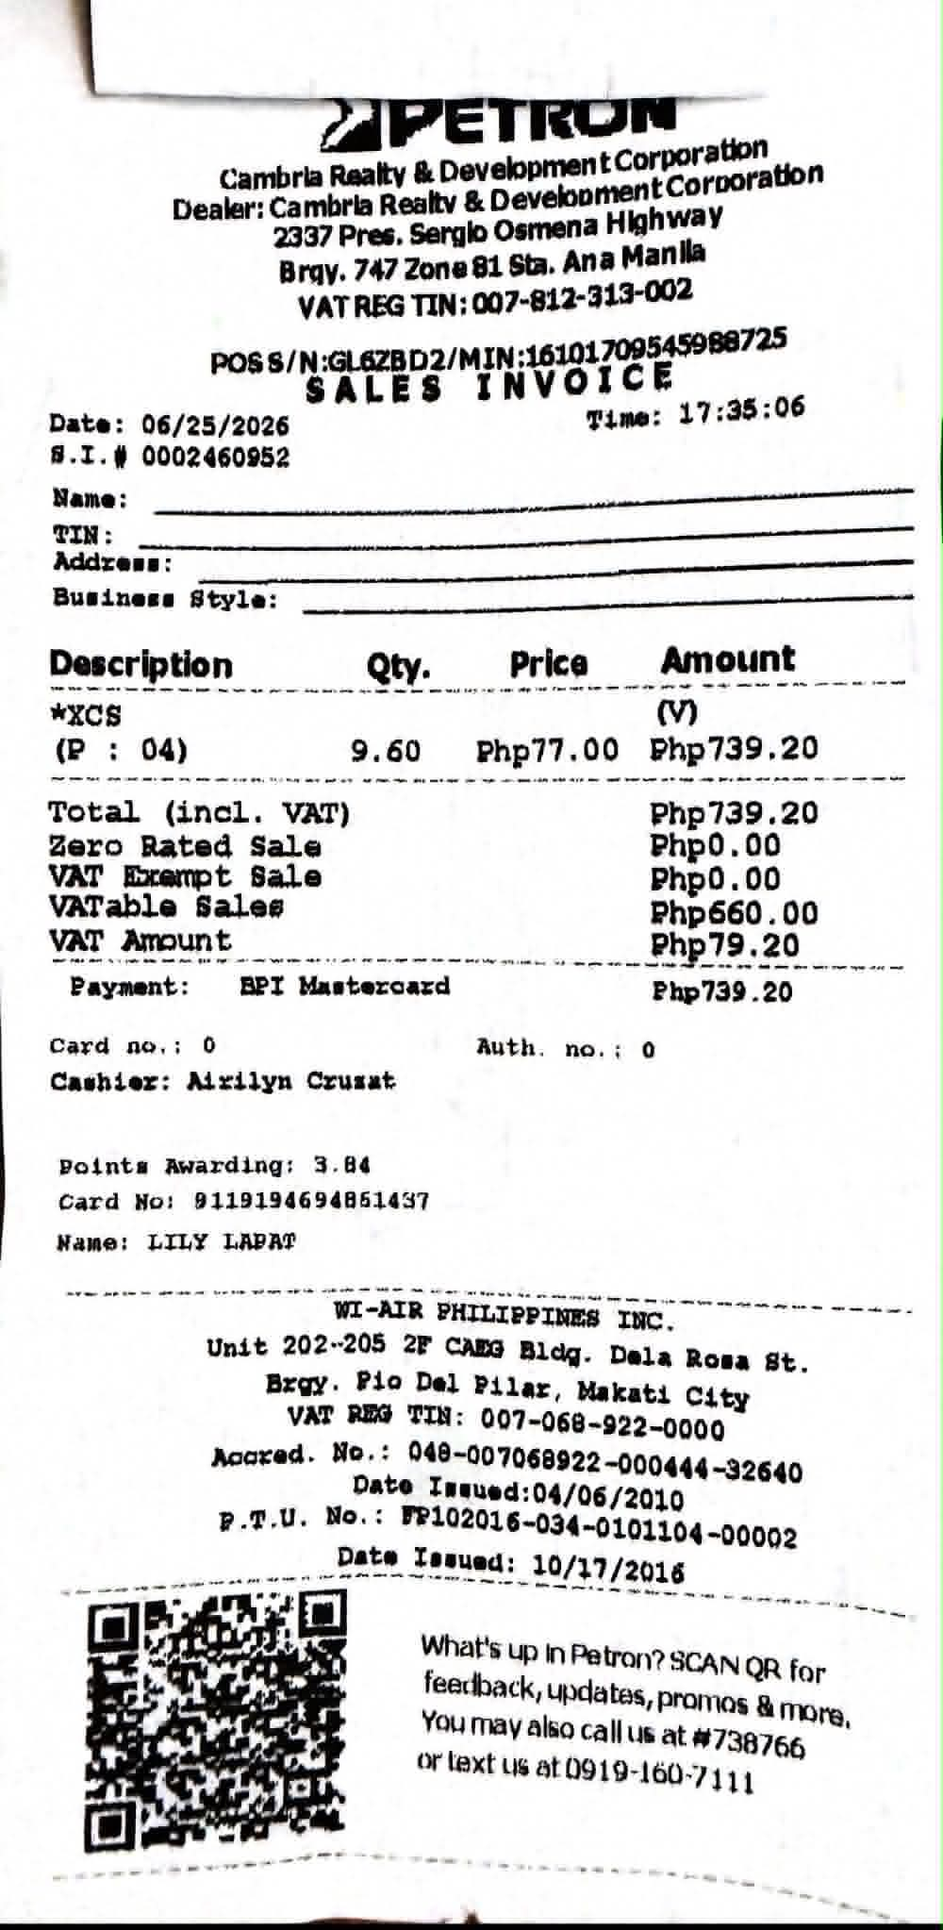
Figure X. Receipt of First Fuel Pump (9.6L at 25%)
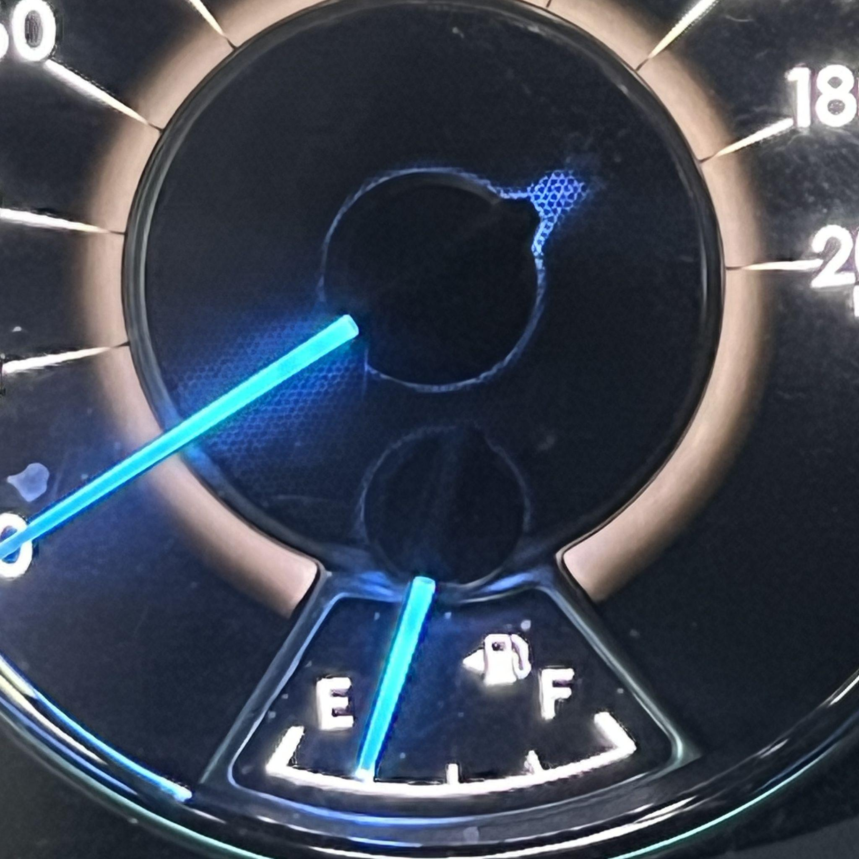
Figure X. Fuel Level Reading After First Pump
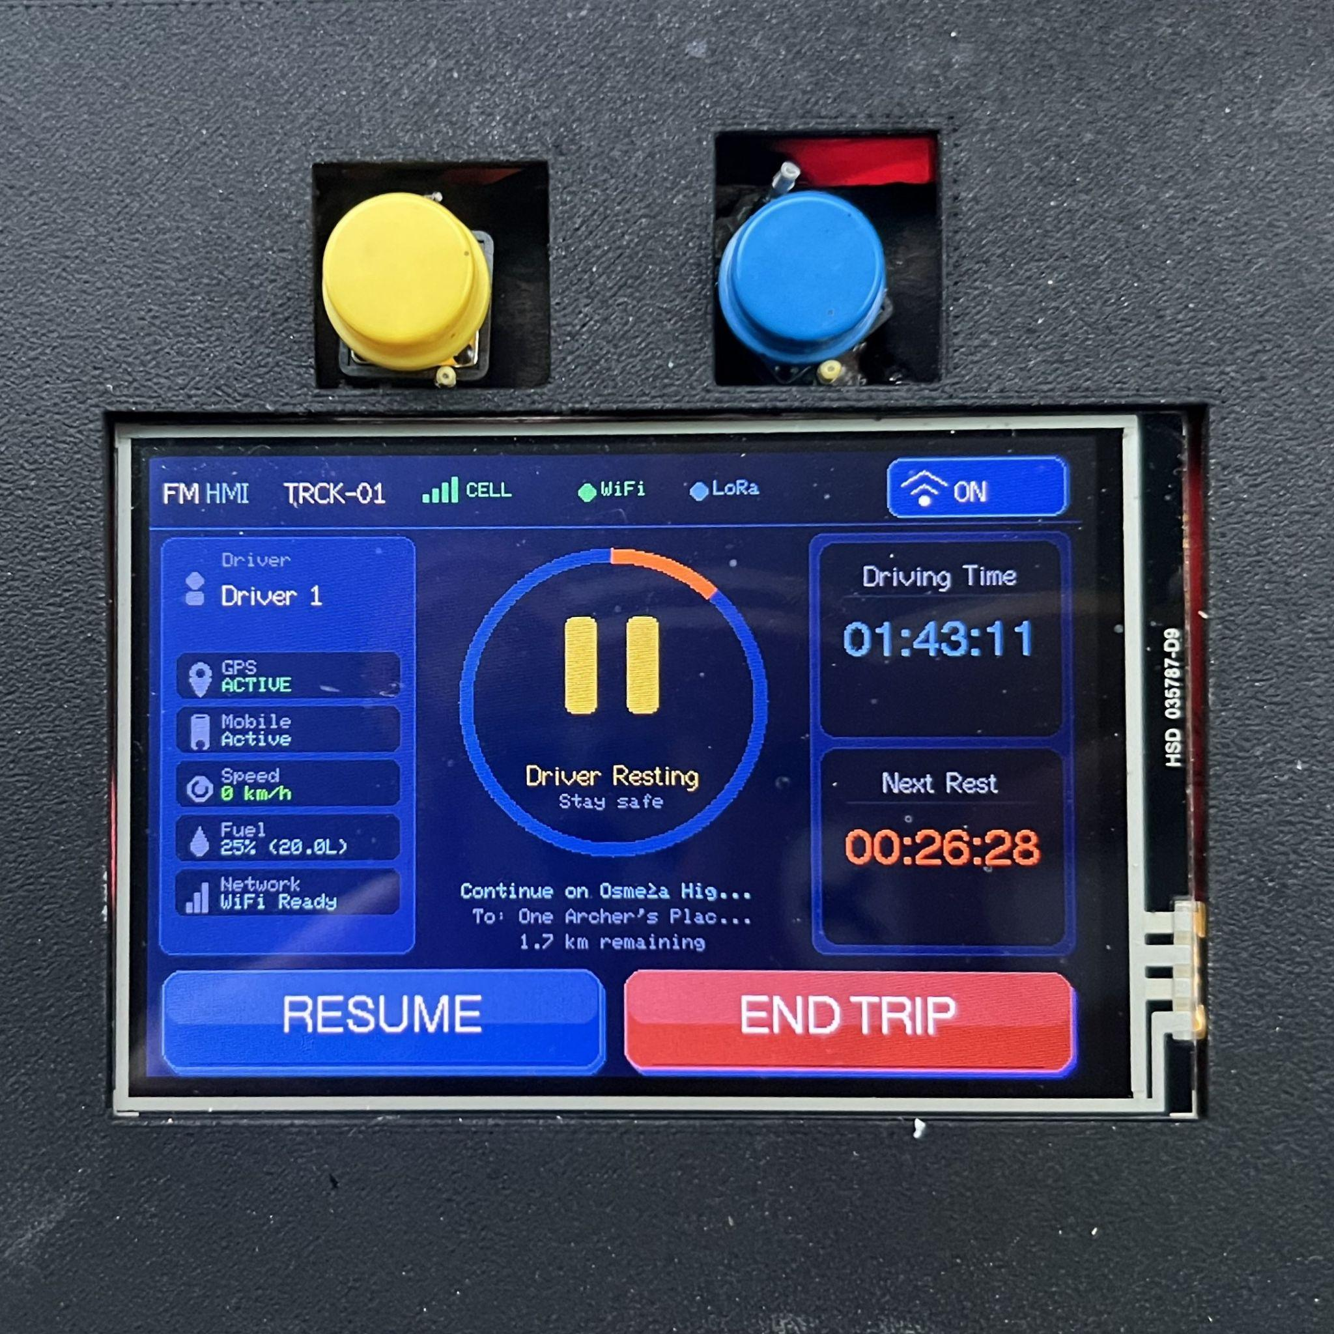
Figure X. HMI Display Showing Fuel Level in Liters and Percentage After First Pump
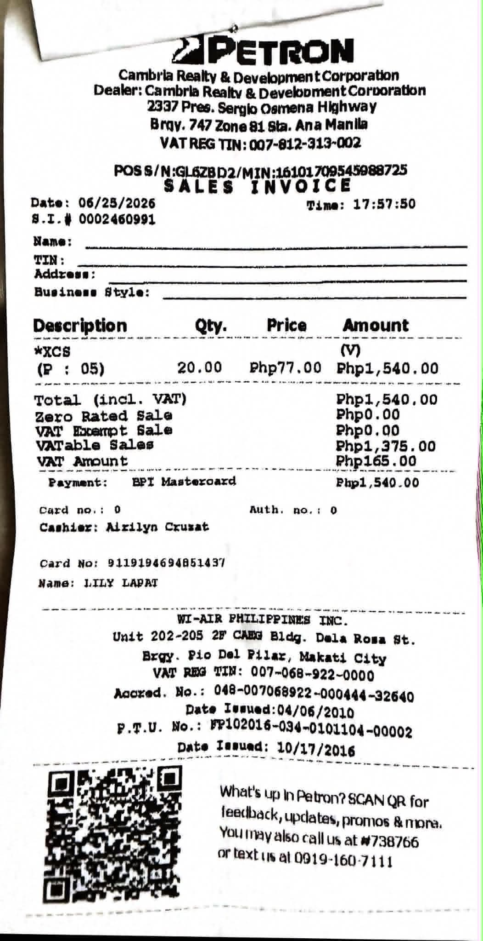
Figure X. Receipt of Second Fuel Pump (20L at 51%)
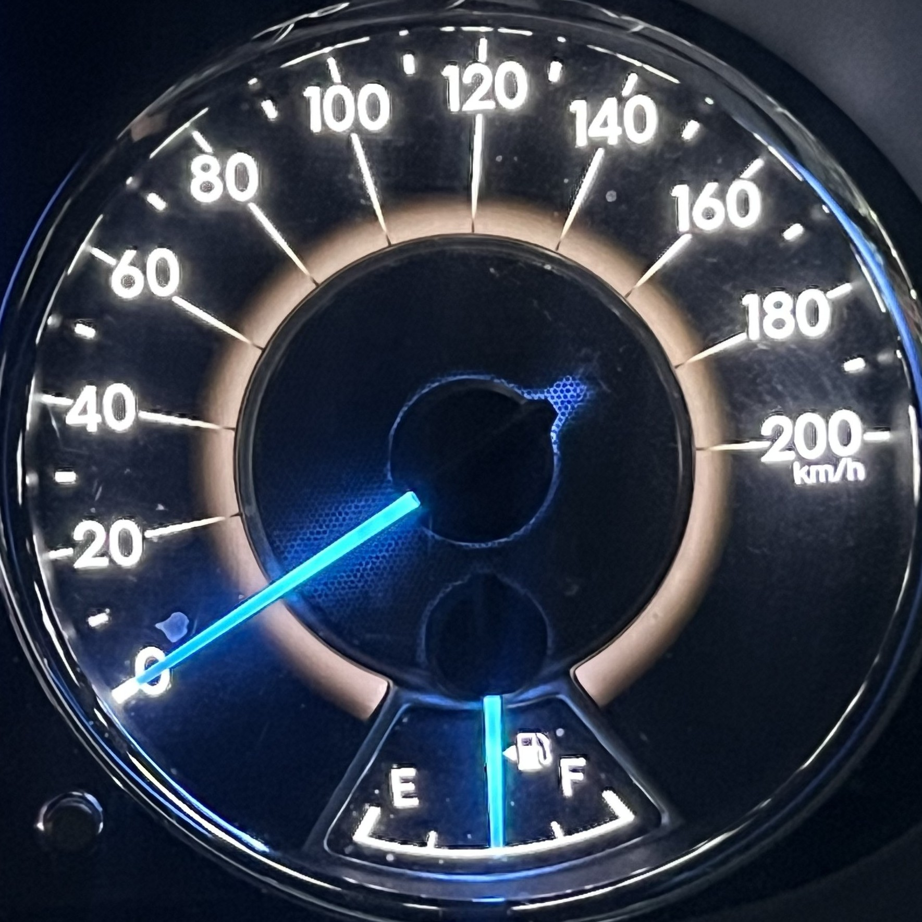
Figure X. Fuel Level Reading After Second Pump
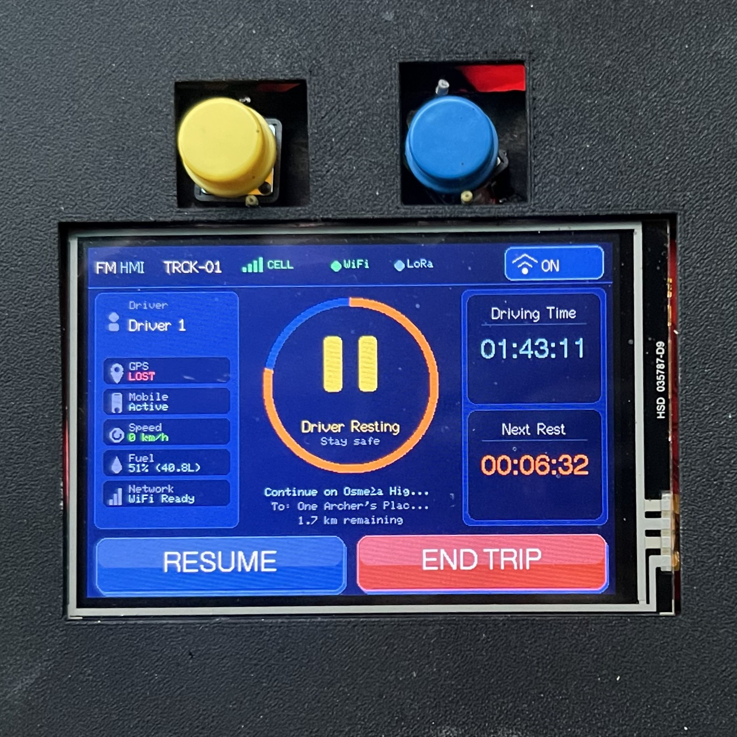
Figure X. HMI Display Showing Fuel Level in Liters and Percentage After Second Pump
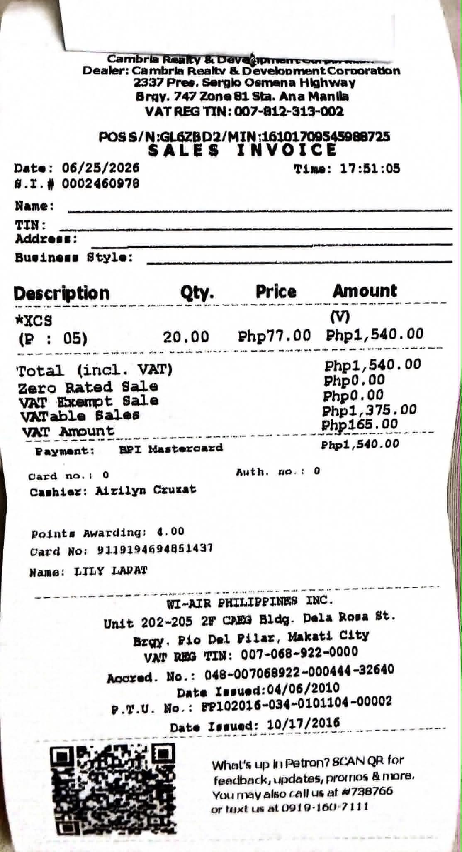
Figure X. Receipt of Third Fuel Pump (20L at 79%)
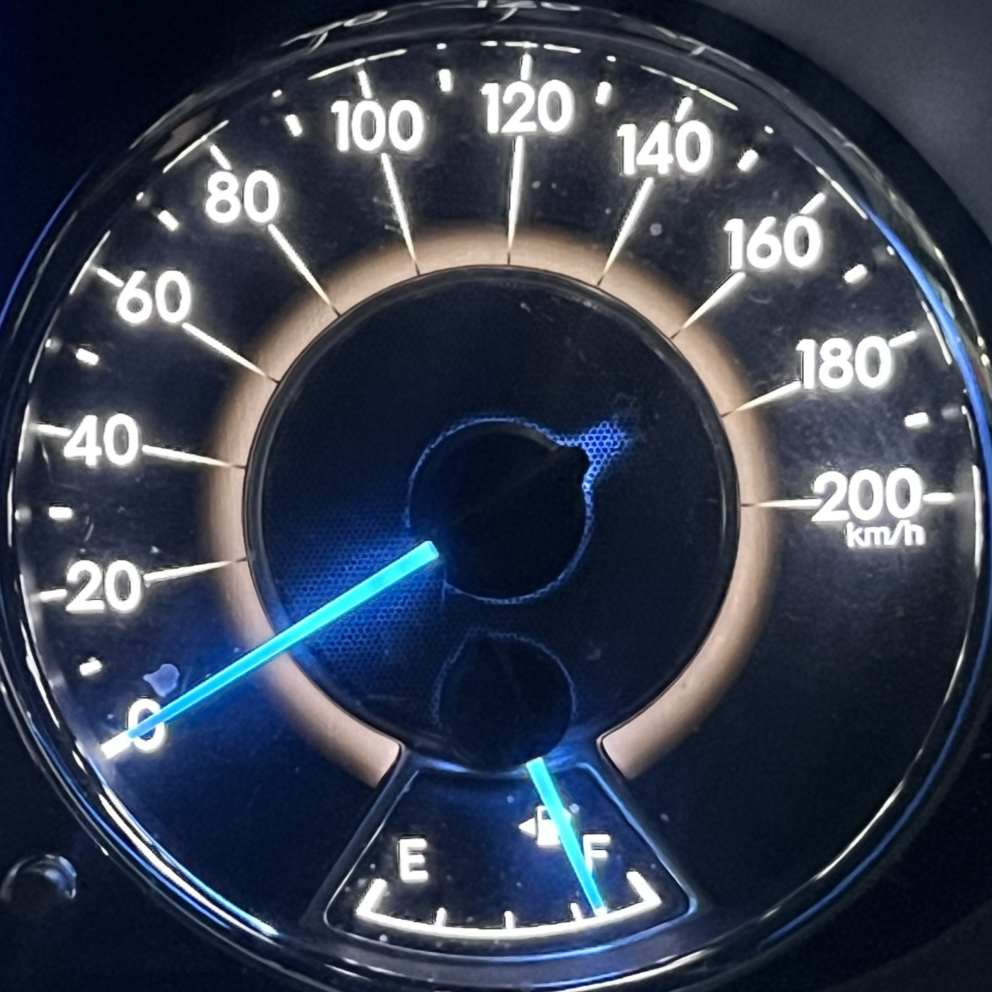
Figure X. Fuel Level Reading After Third Pump
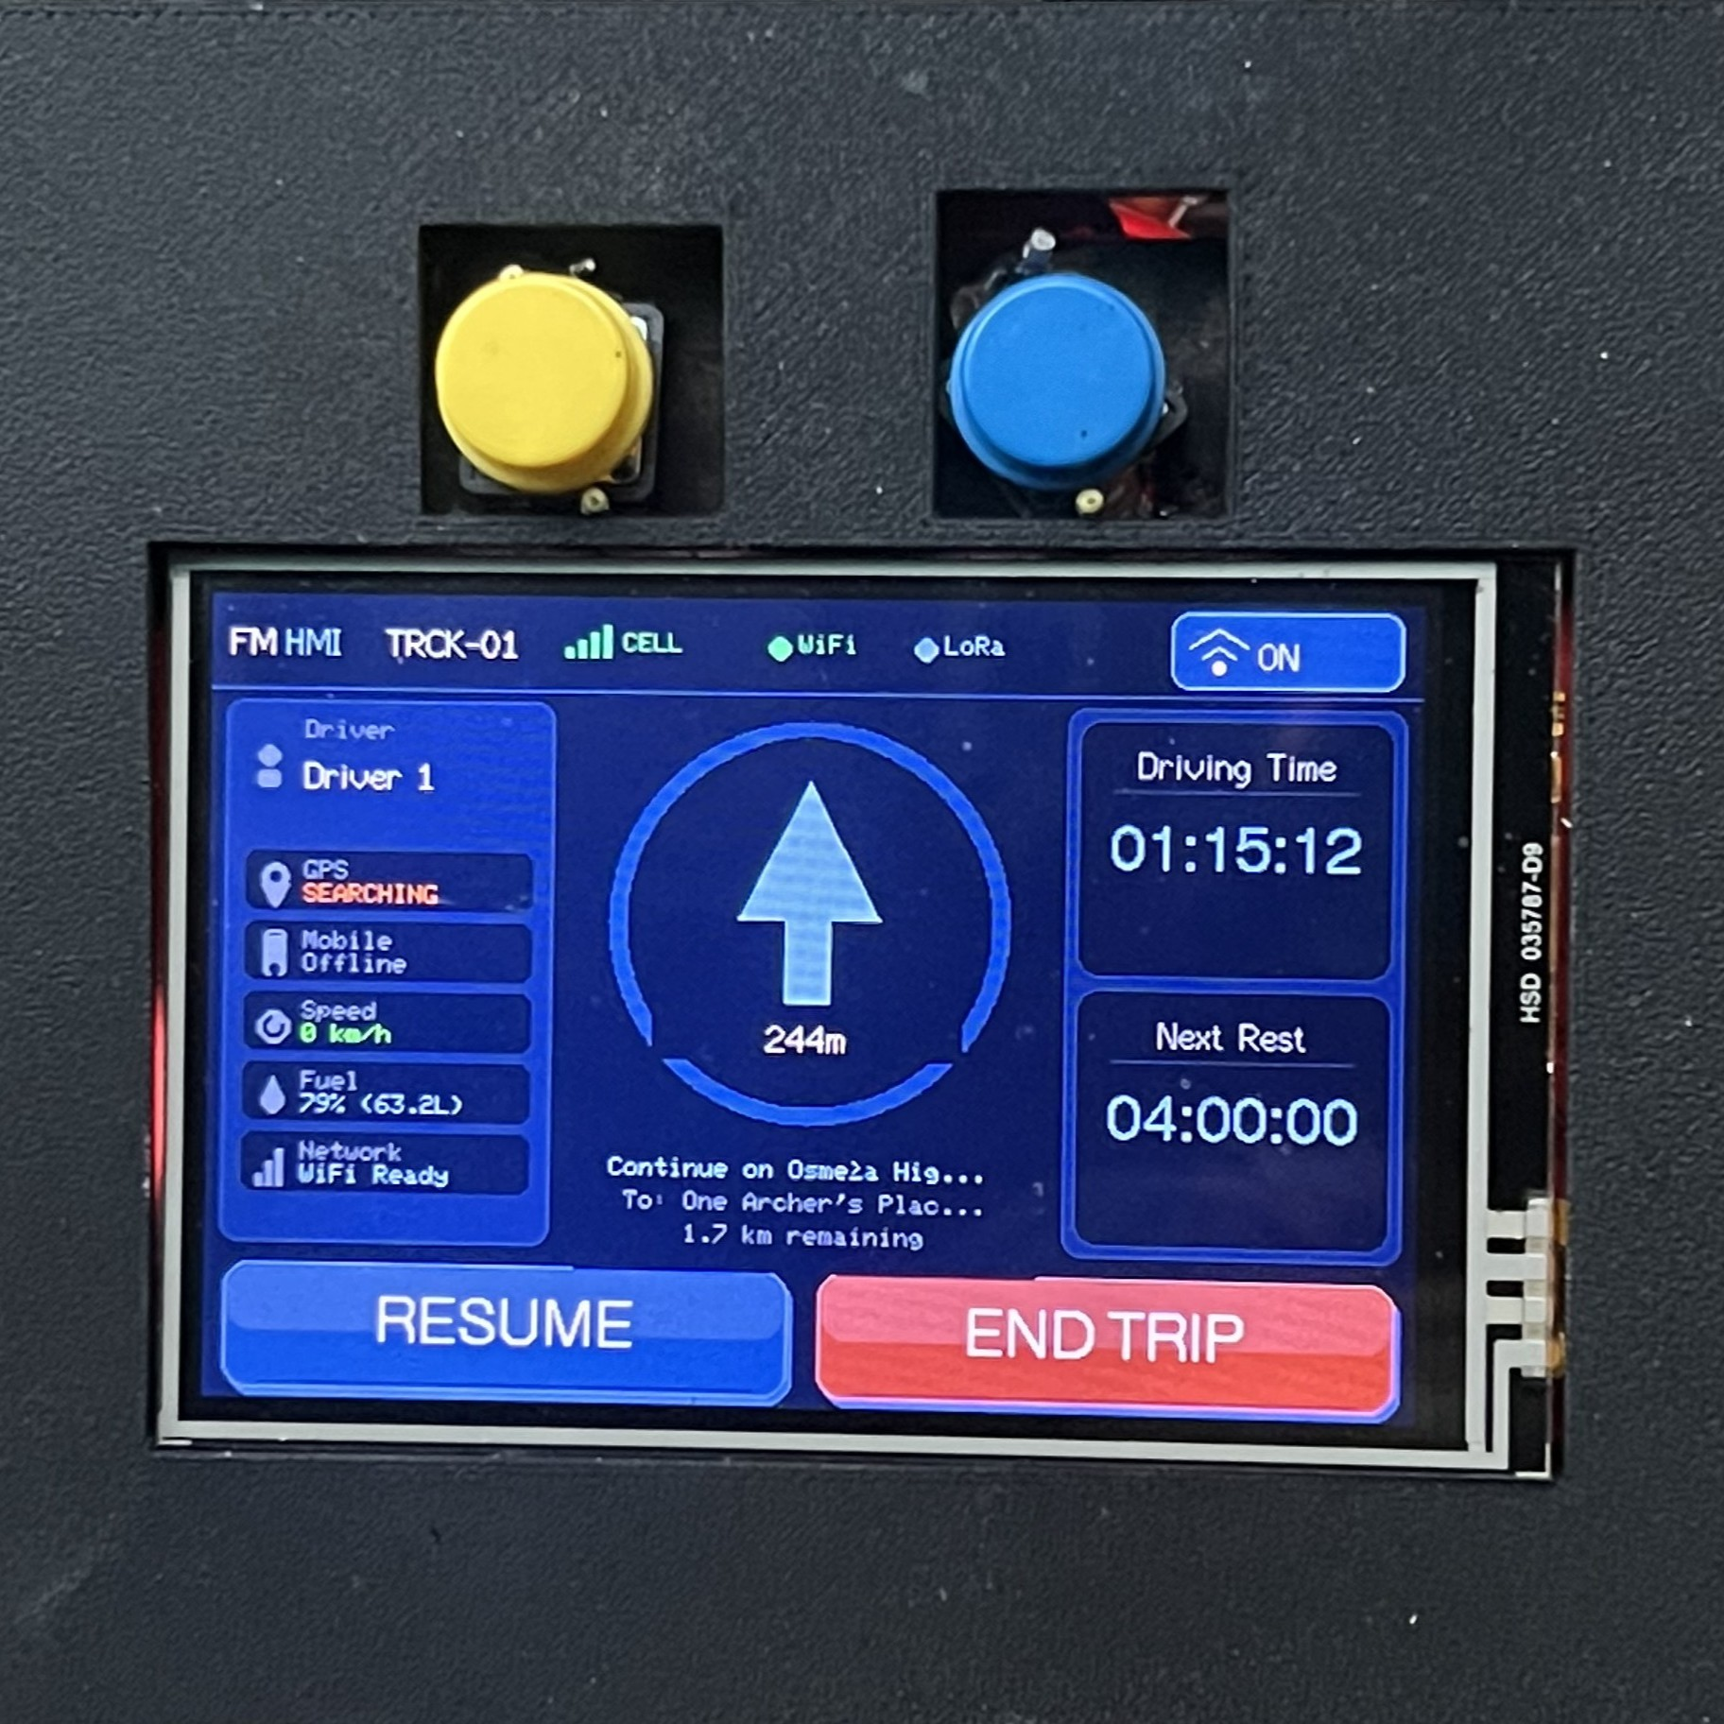
Figure X. HMI Display Showing Fuel Level in Liters and Percentage After Third Pump
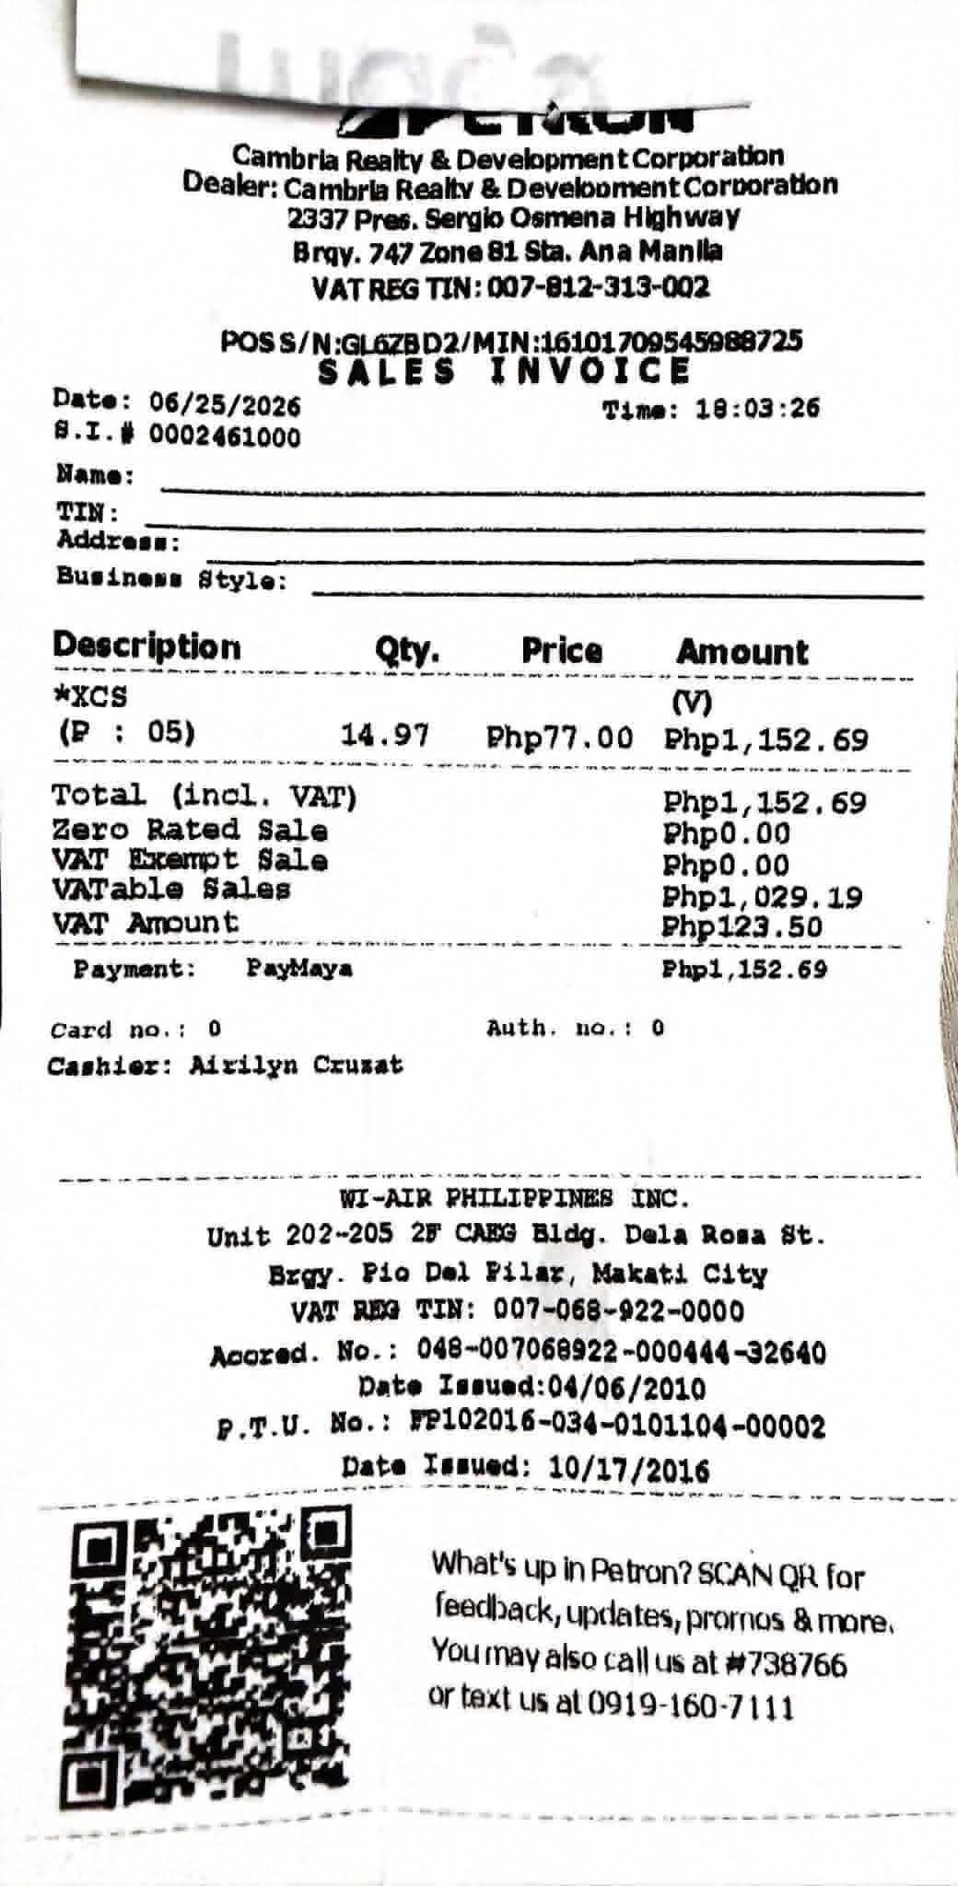
Figure X. Receipt of Fourth Fuel Pump (14.97L at Full Tank)
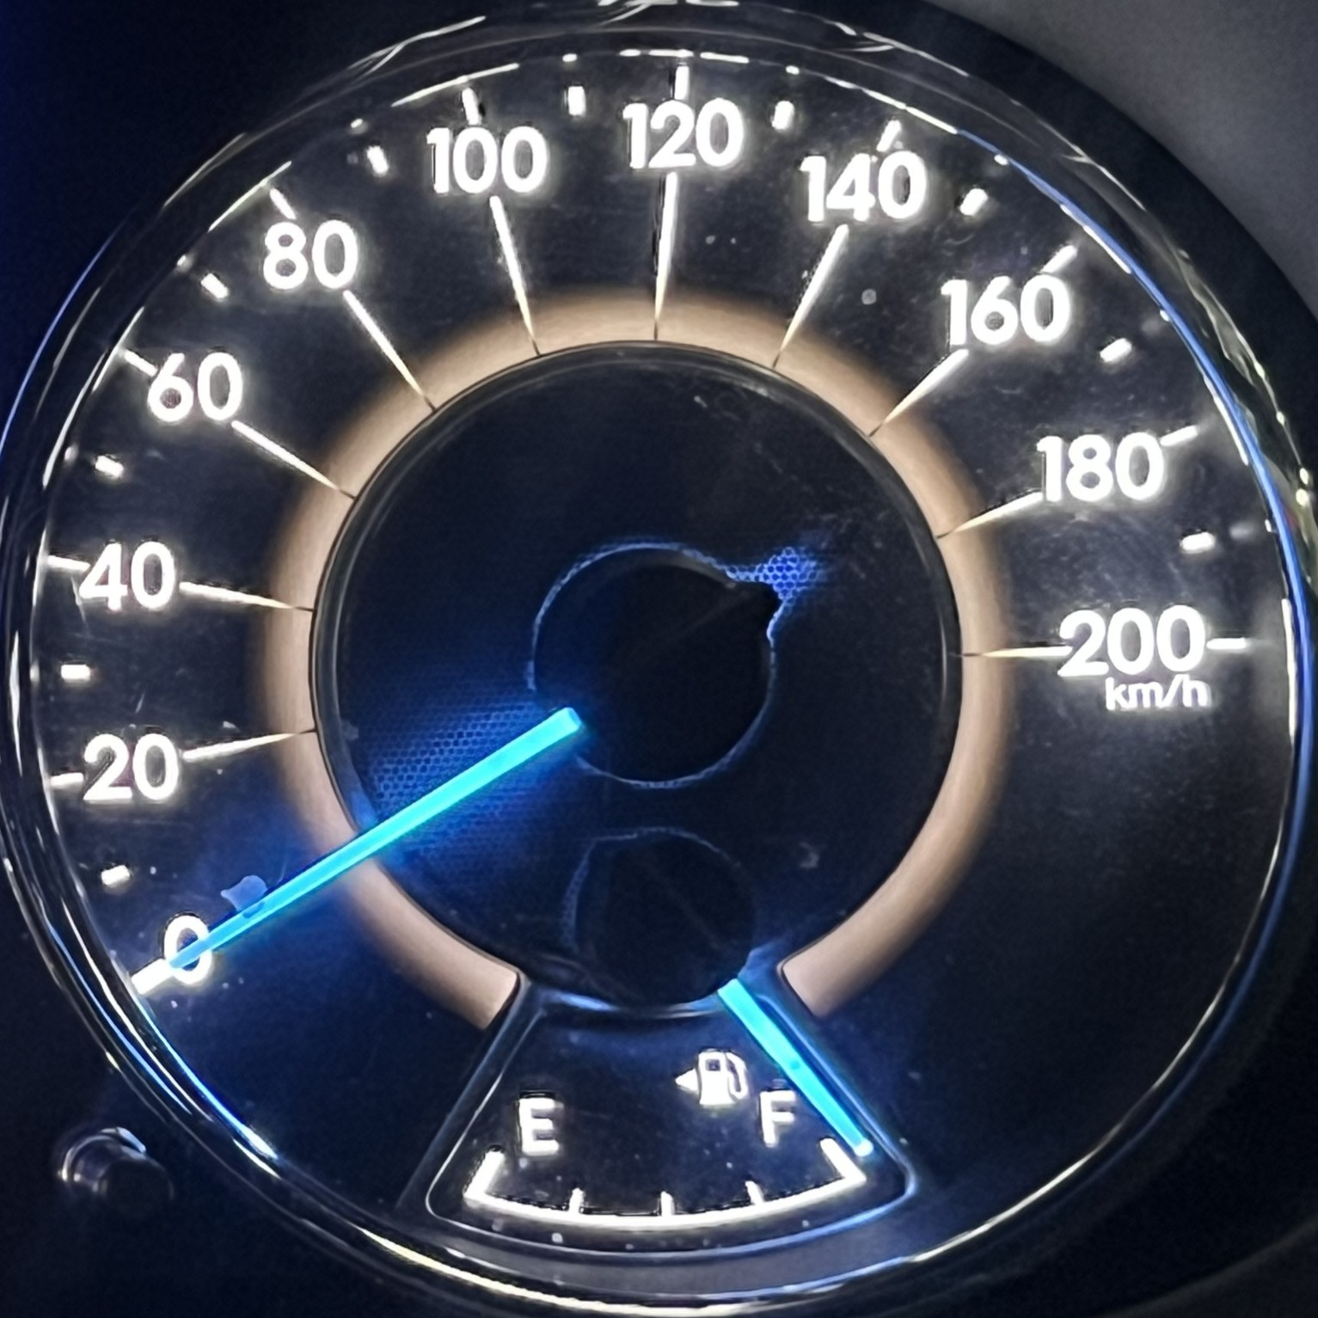
Figure X. Fuel Level Reading After Fourth Pump
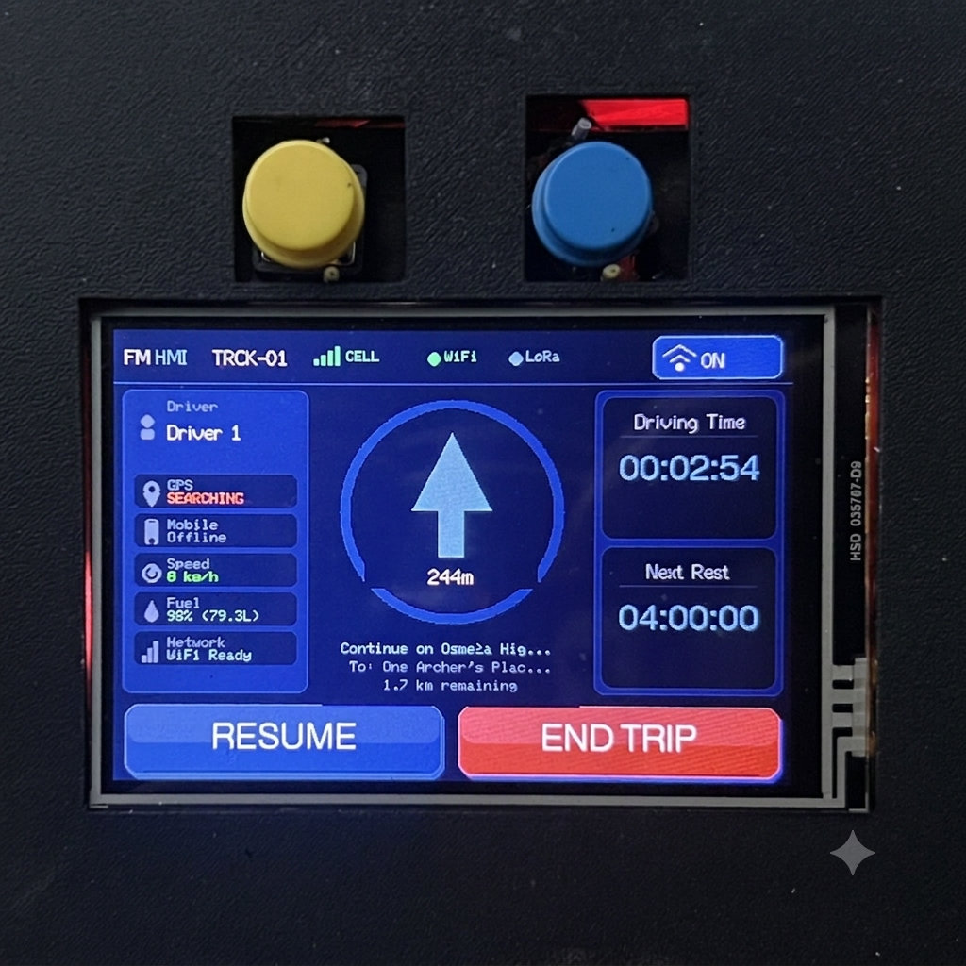
Figure X. HMI Display Showing Fuel Level in Liters and Percentage After Fourth Pump

